**SPRINT-3**

|  |  |
| --- | --- |
| Date | 07 November 2022 |
| TEAM ID | PNT2022TMID53703 |
| Project Name | IOT BASED SMART CROP PROTECTION SYSTEM FOR AGRICULTURE |
| Maximum mark | 20 marks |

STEP 1: SIMULATED PROGRAM TO GET THE RANDOM VALUES

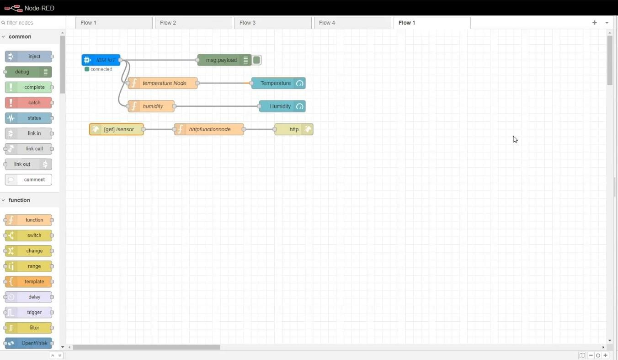

STEP 2: GENERATE DEBUG MESSAGE FROM IBM WATSON IOT PLATFORM AND CONNECT THE NODES.

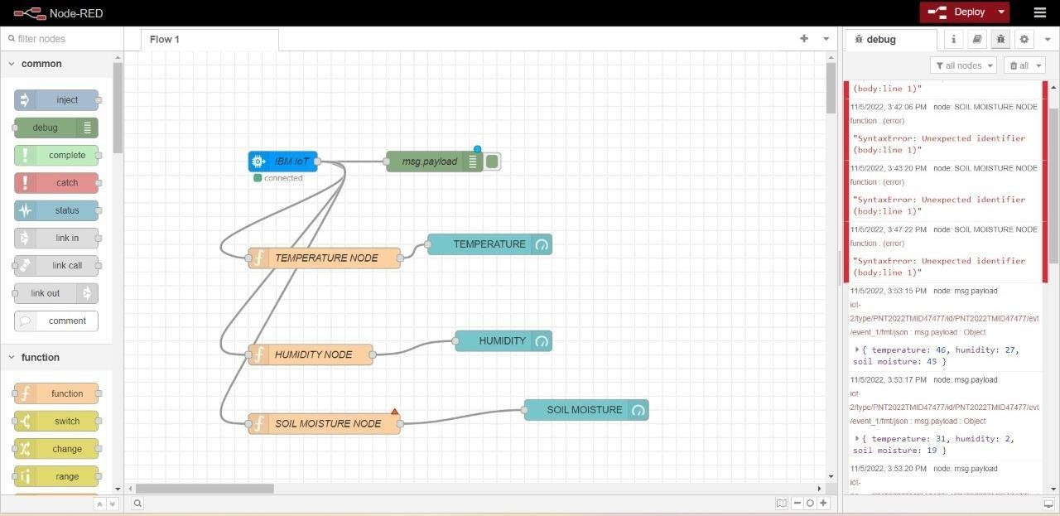

STEP 3: GENERATE THE SOME OUTPUT FROM RECENT EVENTS

(i)

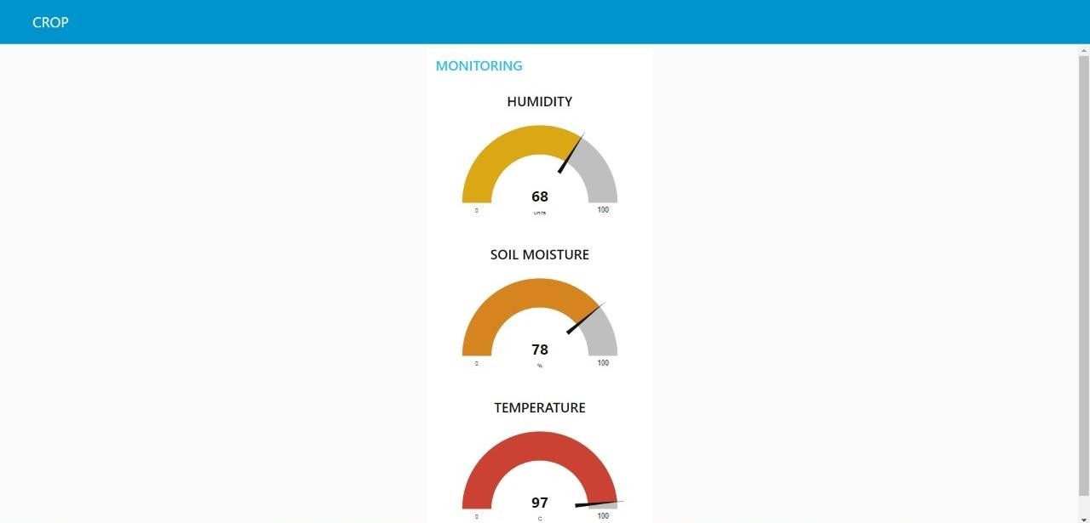

(ii)

